|  |  |
| --- | --- |
| **Key Vocabulary** | |
| Species | a group of similar living things that are capable of interbreeding |
| Vertebrates | Animal with a backbone (fish, amphibians, reptiles, birds, mammals |
| Invertebrates | Animals without a backbone (insects, spiders, snails, worms) |
| Flowering | Plant that produces flowers, seeds or fruits |
| Non-flowering | Plant that does not produce flowers, seeds or fruits |
| Characteristics | a feature or quality belonging to an animal or plant |

 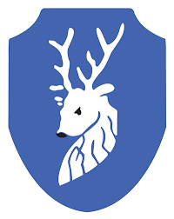

**Career links:**

Horticultural Scientist – Identifies, classifies, records and monitors plant species

Biologist - Studies living things, including people, animals and plants, along with the environments they live in.

**Prior Learning**

**In Year 3 and 4, pupils learnt…**

That animals and plants can be groups in different ways.

A classification key helps to group, identify and name plants and animals.

**Did you know …**

Mushrooms are not plants?

**Classification Key**

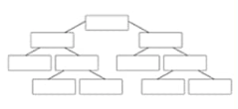

CLASSIFICATION - Cycle A

SPRING Term 1 Y5/6

**Topic: Science**

**Key Knowledge**

Living things can be formally grouped according to characteristics.

Plants are classified into two main groups:

1. Flowering plants
2. Non-flowering plants

Animals can be divided into two main groups: those that have backbones (vertebrates); and those that do not (invertebrates).

Vertebrates can be divided into five small groups: fish; amphibians; reptiles; birds; and mammals. Each group has common characteristics.

Invertebrates can be divided into a number of groups, including insects, spiders, snails and worms.

Penguins are birds. There are many types of penguins. They can be classified by their physical features/characteristics.