|  |  |
| --- | --- |
| **New Vocabulary** | |
| Force | Strength or energy used to create a physical action or movement. |
| Contact | Physically ouching |
| Non-contact | Not physically touching |
| Attract | When something pulls together |
| Repel | When something pushes away from each other |
| Poles | The strongest part of a magnet, often found at the ends |

 

**Helpful hints**

Magnets should be stored correctly (without their poles touching) as otherwise the poles of the magnet can change.

**Prior Learning**

**In Year 1 and 2, pupils learnt:**

Examples of everyday materials including wood, plastic, glass, metal, water, and rock.

The shape of some solid objects can be changed by squashing, bending and stretching.

**Did you know …**

That not all metals are magnetic?

A bigger magnet is not necessarily stronger than a smaller magnet?

**Career links**

Magnetic engineer - designs magnets, or machines and devices that contain magnets.

**Key Knowledge**

A force is a push, pull or twist.

When an object moves on a surface, the texture of the surface and the object affect how it moves (increases or decreases the speed). e.g. an ice skater compared to walking on ice in normal shoes.

A magnet attracts magnetic material.   
Iron, nickel and stainless steel are magnetic.

The strongest parts of a magnet are the poles.   
Magnets have two poles – a north pole and a south pole.

If two like poles, e.g. two north poles, are brought together they will push away from each other – repel. If two unlike poles, e.g. a north and south, are brought together they will pull together – attract.

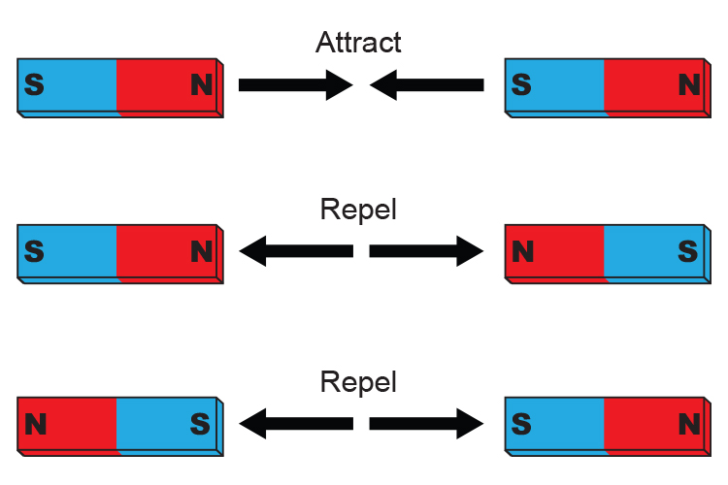

FORCES, FRICTION, MAGNETS Cycle A

Autumn Term 2 Y3/4

**Topic: Science**