|  |  |
| --- | --- |
| **New Vocabulary** | |
| Software | The programs used by a computer. |
| Duplicating | Make an exact copy of something. |
| Modify | Make minor changes to something. |
| Graphics | The use of pictures and texts. |
| Graphic Design / Designer | A graphic designer **creates visuals for all kinds of projects**, from websites to adverts. |

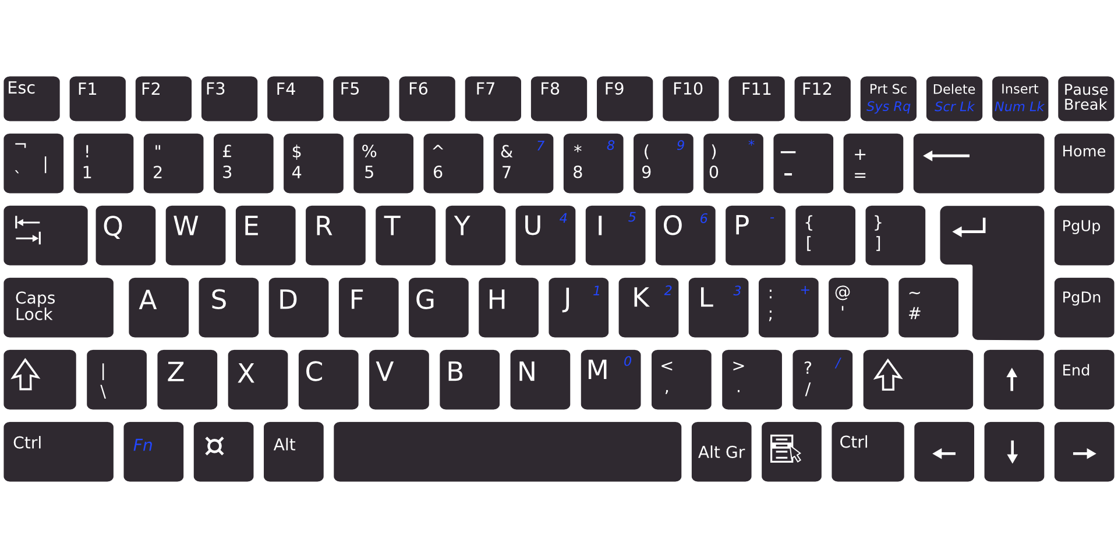  

**Prior Learning**

**In Year 1/2, pupils learned:**

Computers can be used to create art.  
The fill tool will fill an enclosed area with a colour.  
The undo button will correct a mistake.

**In Year 3/4 pupils learned:**

Images can be added, resized and rotated.

Digital images can be changed for different purposes. They can be cropped, cloned, copied and pasted.

**Helpful Hints**

A vector image is an image created using mathematical formulas to represent the image, rather than using a grid of pixels. This type of image is often used for logos and illustrations because it can be scaled to any size without losing quality.  
Software - This unit uses Google Drawings. *Note: if choosing not to use PowerPoint or Slides, pupils will create vector-style drawings rather than true vector drawings.*

**Undo**

**Paste**

**Copy**



**Shortcuts save us time**

**Career links**

Graphic designers often use vector drawing  
 programmes when creating their designs.   
They use the software and digital tools to lay   
out elements of a design, adjust it and ensure   
it is clear, eye-catching and effective in communicating a message or brand.

**New Knowledge**

**Vector graphics** are made on the computer using lines and shapes to form a complete image. They are different to freehand drawings because they can be easily resized and edited using **software**.

Each element added to a vector drawing is an object. We can **modify** objects by changing their size, colour, layers etc.

Vector drawings are created using layers. Here are some examples:



The order of layers can be changed by sending objects backwards or forwards.

Computing Cycle A

Autumn Term 2 Y5/6

**Topic: Vector Graphics**