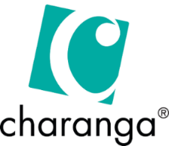

**New Knowledge**

We can read and play the treble clef notations for the notes E, D and C

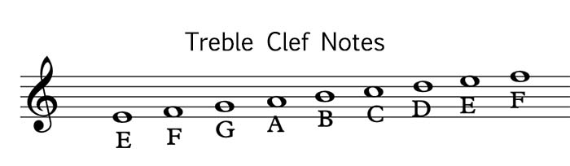

We can play simple tunes on the treble clef stave which contains the notes B, A, G, E, low D, C and High D.



**Music  
Topic:** *Recorder*

*Music and Technology*

**Helpful Hints – Treble clef**

**Prior Learning**

**In Year 1/2, pupils learned:**

Pulse is a steady beat in a song. Rhythmic patterns are a series of long and short sounds. Pitch is high and low notes.

**Prior Learning**

**In Year 3/4, pupils learned:**

The parts of a recorder and how to create different pitch sounds. A crotchet beat is 1 beat long, a quaver beat is ½ a beat long and a minim beat is 2 beats long.

**Context - History of Music**

Do What You Want To – Soul

The tambourine is an important instrument in this song. Instruments that involve jangling pieces of metal fixed on a wooden frame can be found all over the world.

It’s All About Love – Pop

Many pop songs have used the Blues as the basis of their structure.

Sunshine On a Rainy Day – Soul

It is very common for songwriters to use weather to describe human emotions.

Cycle A

Spring 1 5/6

|  |  |
| --- | --- |
| **New Vocabulary** | |
| Dynamics | How loud or quiet music is. |
| Timbre | the specific tone or quality that a certain instrument or voice has. |

