|  |  |
| --- | --- |
| **New Vocabulary** | |
| Windway | The narrow slot that you blow into. |
| Head Joint | The top of the recorder. |
| Foot Joint | The bottom of the recorder. |
| Tone hole | Holes along the body joint of the recorder are what controls the pitch of the sound as you play |

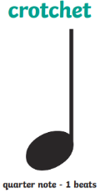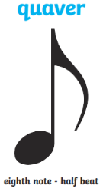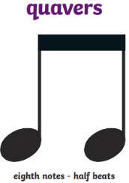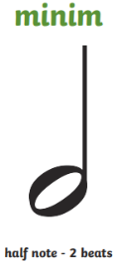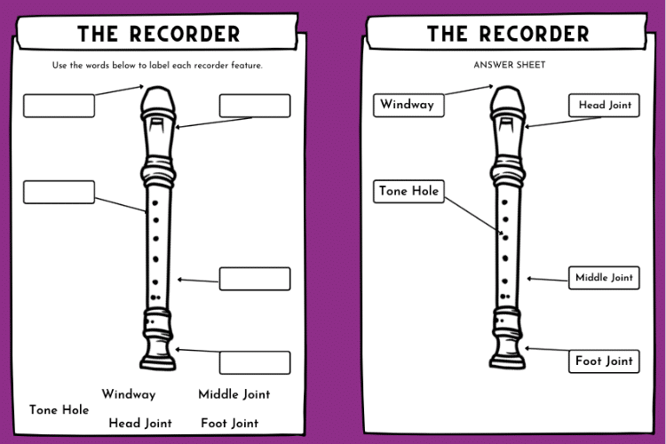

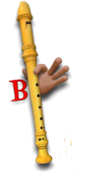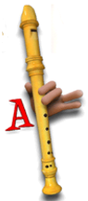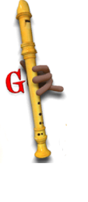

**Helpful Hints – Parts of the recorder**

**Prior Learning**

**In Year 1/2, pupils learned:**

Pulse is a steady beat in a song. Rhythmic patterns are a series of long and short sounds. Pitch is high and low notes.

**New Knowledge**

We can read and play the treble clef notations for the notes B,A and G.

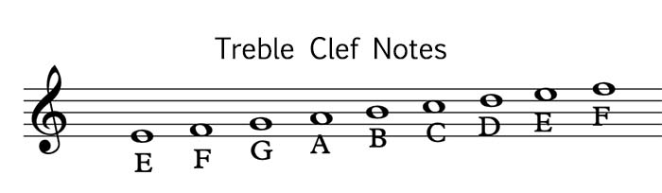

We can read the standard notation for crochets, quavers and minims.

We can play simple tunes on the treble clef stave which contains the notes B, A and G.

**Music  
Topic:** *Recorder*

*More Musical Styles*

**Context - History of Music**

Friendship Song – Pop

Different countries have their own versions of Pop music, like K-Pop (from South Korea), Zim Pop (from Zimbabwe) and Britpop (from the UK).

Family – Rock

Rock music grew out of Rock ‘n’ Roll and the Blues. Rock music is a powerful style dominated by the electric guitar, but there are some songs that don’t feature a guitar at all.

Come On Over – Soul

Soul is a popular style of music that was developed by African Americans in the 1950s.

Cycle A

Spring 1 Y3/4