|  |  |
| --- | --- |
| **New Vocabulary** | |
| Improvising | Make music up on the spot. |
| Composing | Making your own music. |
| Melody | A melody is made up of a mixture of high and low pitch sounds played one after the other. |
| Lyric | The words in a song. |

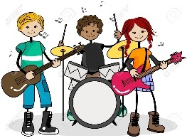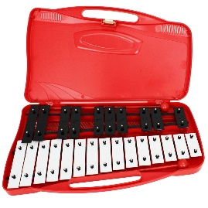  

**Music  
Topic:** *My Musical Heartbeat*

Cycle A

Spring 1 Y1/2

**Career links   
Composers** – People who write music.

**Artists -** Artists perform their music. They start with a pulse, then add rhythmic patterns, melodies and lyrics to form a full song.

**Helpful hints**

The notes on a glockenspiel get higher in pitch the smaller the keys are.

Lower pitch Higher pitch

**New Knowledge**

**Pulse** is a steady beat in a song.

**Rhythmic patterns** are a series of long and short sounds.

Pitch is high and low notes.

We can improvise on a glockenspiel using the notes C, D and E.

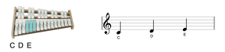

We can play a piece of music using C D E F G.   


CDEFG