|  |  |
| --- | --- |
| **New Vocabulary** | |
| Reared | Animals born, raised, bred and kept in captivity to become food. |
| Processed | Food or drink that has been changed when it has been made or prepared. |
| Storage | Keeping food in safe places, such as the fridge, freezer. |
| Hygiene | The way we handle, prepare and store food safely to stop any food related illnesses. |
| Cross contamination | The accidental sharing of harmful bacteria from one food or utensil to another. |
| Seasonality | The time of year when the food is its best either in harvest or in its flavour. |
| Bacteria | Very small living things. Most are harmless but some can spoil food (make it go off) and cause food poisoning. |

 

**Career links**

There are many career links that can be found with using food. You could become a **chef** or with your knowledge and understanding of the food types for a healthy diet you could become a **nutritionist.**

**Did you know …**

Not all bacteria are bad for you. In fact, we use bacteria when we make some food like yoghurts and cheese. We need to just make sure all food is stored and prepared correctly to avoid the harmful bacteria.

**Revisit – cutting techniques**

The fork secure The bridge The claw

Design and Technology Cycle A

Spring Term 2 Y5/6

**Topic: Super Seasonal Cooking**

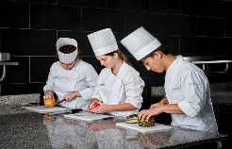

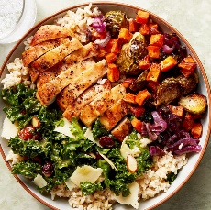 s

**Prior Learning**

**In Year 1/2, pupils learned:**

There are different cutting techniques such as the fork secure method and the bridge method.

Having a healthy balanced diet is important because we need all the vitamins and nutrients from the different types of food. Having a range of these makes our bodies strong and fit to fight illnesses.

When we make food, it is important to include healthy ingredients, such as meat and a range of different vegetables.

**In Year 3/4 pupils learned:**

The claw method is used to food into slices.   
The bridge method is used when we would like to cut things in half.

Pupils learnt how to grow a range of food and how these are then used when cooking to make a meal.

**New Knowledge**

Seasonality is the time of year food is ready to eat and when certain foods are more flavourful and nutritious.

Foods can be grown, reared, caught and processed. Reared food are animals that have been raised, bred and kept in captivity to become food.

For a meal to be healthy, you need to have a balance of different types of food including carbohydrates, proteins, fats and fibre.

When we work with food, we have to store it safely. When we cook with meat and fish, these need to be stored in a fridge to prevent the growth of germs.

Depending on what we are cutting will help us decide what cutting technique to use.

When cooking food, we must make sure we follow the instructions of cooking times to ensure all meats are cooked for the appropriate amount of time.