|  |  |
| --- | --- |
| **New Vocabulary** | |
| Starch | A type of carbohydrate that is found in certain foods. It gives people quick energy when eaten. |
| Sugars and fats | These are found in a range of food and when eaten give you energy and make you feel full. |
| Seasonality | The time of year when the food is its best either in harvest or in its flavour. |
| Flavour | How something tastes. |
| Home grown | Food grown in a garden or personal space. |
| Naturally grown | Food grown with very little chemicals or any modifications. |
| Organically grown | Grown on farms that use methods to benefit the environment, animals and people. |
| Produce | Food that is grown or raised on farms, like fruit and vegetables. |

 

**Did you know …**

Fat is an essential part of people’s diets, as long as you have it in moderation.

**Cutting Techniques!**

The fork secure The bridge NEW TO Y3/4! The claw

Design and Technology Cycle A

Spring Term 2 Y3/4

**Topic: Edible Garden**

**Career links**

Learning how to safely grow, store and prepare food allows us to gain knowledge for lots of different careers. This could kick start your interests as a **chef** or learning about where food comes from may make you want to further explore **farming** or being an **agriculturalist.**

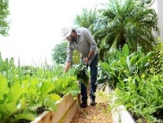e

**Key Knowledge**

When we are making food, it is best to use food that is in season to get the best flavours.

To get a balanced, healthy diet we need to know how many types of foods we need to have a day. We need at least 5 fruit and vegetables a day, 5 starchy foods, 2 protein food and 3 dairy foods a day.

There are different ways ingredients can be grown. They can be home grown, naturally grown and organically grown. The way they are grown may affect how they look and taste.

By following instructions, we can grow our own edible ingredients to use in our meal.

The claw cutting method is where we safely make a claw with our non-cutting hand on the top of the ingredient (to secure it in place) and then you cut.

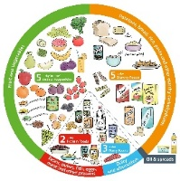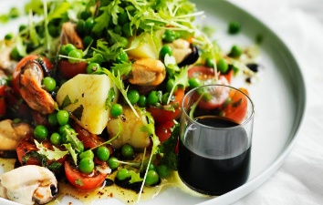

**Prior Learning**

**In EYFS, pupils learned:**

We need to think about the amount of food we eat for different types of food to be healthy.

It is healthy to have at least 5 fruit and vegetables a day.

**In Year 1/2, pupils learned:**

There are five different food groups. These are carbohydrates, fruit and vegetables, protein, fats and sugars and dairy.

Some food comes from the land such as fruit and vegetables and some food comes from the sea such as fish.

**Helpful Hints!**

In Spring, fruit and veg that are in season could include spinach, lettuce, apples, limes, peas and radishes.