|  |  |
| --- | --- |
| **New Vocabulary** | |
| Chop | Cutting things into smaller pieces with a knife. |
| Dressing | A type of sauce you add to food for more flavour. |
| Zest | The peel of a citrus fruit used to flavour food. |
| Food hygiene | How we handle, prepare and store food safely to avoid spreading germs. |
| Protein | Protein rich food like meats and fish give energy and help the body to grow and repair. |
| Carbohydrate | Carbohydrate rich food like bread and pasta provide the body with energy and needed fats. |
| Dairy | Dairy products like milk and cheese give us calcium for strong bones. |

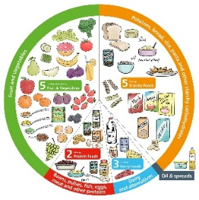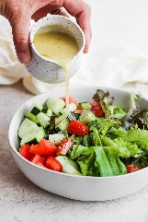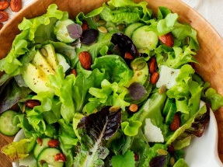 

**Career links**

Creating salads and learning all about the different food groups may lead you down a path of wanting to be a chef, working with lots of different foods daily and finding new and exciting ways to prepare and present them.

**Cutting Techniques!**

The fork secure The bridge

The fork method – You place the fork into the food to keep it secure and then you slice with the knife in front of the fork.

The bridge method – pinch food between your thumb and fingers making a bridge shape. Put the knife under the bridge and cut the food in half.

**Helpful Hints!**

Some food grows on trees and bushes like apples and blackberries.

Some food grow underground like carrots and potatoes.

Some grow on top of the soil with their roots underground like pumpkins or cabbages.

**Key Knowledge**

The food we eat can be split into different groups. These are: fruit and vegetables, starchy food (carbohydrates), dairy, protein and sugars and fat.

We need to eat a balance of these foods to have a healthy diet.

Some food is grown like vegetables and some food is caught like fish.

We can use measuring spoons, zesters and juicers to prepare different foods.

When we handle food, we must correctly store it and handle it to stop germs from spreading.

**Prior Learning**

**In EYFS, pupils learned:**

We use a knife to cut things into smaller things.

Fruit and vegetables are healthy for you to eat.

Design and Technology Cycle A

Spring Term 2 Y1/2

**Topic: Sensational Salads**