|  |  |
| --- | --- |
| **New Vocabulary** | |
| Habitat | An environment where plants and animals can make a suitable home |
| Insect | Small animals that have six legs and often one or two pairs of wings |
| Conditions | The state something is |
| Suitable | Adapted for a use |
| Leaf litter | Pile of dead leaves, twigs and bark that have fallen to the ground |
| Micro-habitat | A small place within a habitat where things can live and survive |

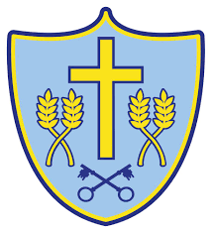 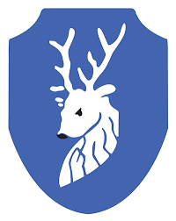

MINIBEASTS - Cycle A

Spring 1 - Y1/2

**Topic: Science**

**SIMPLE FOOD CHAIN**

**New Knowledge**

A minibeast is a small animal such as a slug and a millipede. An insect is an animal that has six legs and generally one or two pairs of wings such as ants, woodlice and dragon flies.

Animals and plants live in a habitat to which they are suited. This means that animals have suitable features that help them move and find food.

Plants have suitable features that help them to grow well.

Within a habitat there are different micro-habitats e.g. in a woodland - in the leaf litter and under logs and stones. These micro-habitats can be light or dark, damp or dry.

Plants and animals in a habitat depend on each other for food and energy. The way that animals get their food from plants and other animals can be shown in a food chain. Woodlice eats leaf litter, and birds eat woodlice. A grasshopper eats grass and a frog eats grasshoppers.

**Career links:**

Entomologists and Insect Scientists – People who study insects. They research insects for a purpose.

**Did you know …**

That all minibeasts are not insects?

An animal’s habitat is not its ‘home’?

The arrows in a food chain does not mean ‘eats’?

**Prior Learning**

**In EYFS, pupils learnt:**

Minibeasts are small animals such as caterpillars, butterflies, spiders etc.

Minibeasts live in dark, damp places.

